GoDaddy Website Builder Tutorial
Olivia Lazarchick

GoDaddy’s Website Builder is an easy way for beginners to experiment with web design. There is no coding experience needed, just an understanding of the tools. Hundreds of customizable designs are available for as low as $1.00/ month.
See www.lazarchick.com, a website I created with Website Builder, as an example.

Purchasing a Free Domain from GoDaddy with Website Builder
- Go to GoDaddy.com and click the green “Get Started” button under Website Builder.
- Hit the “Get Started” button again once you have read Plans & Pricing.
- Choose the plan that works best for you and click the orange “Continue” button.
- Now search for the domain you are interested in. If it is available, click the orange “Add & Continue” button.
- Once you are satisfied with your current order, click the orange “Proceed to Checkout” button.

How to Use Website Builder
- Sign in to GoDaddy.com and make sure you are on your Account page.
- Click on Website Builder, the third link under the Products tab.
- Click “Launch” next to the domain name that you would like to design.
- If you would like to start with a theme for your site, choose one now.
- Click “Edit Site” under Site Info and continue to the editing page.
- Use the given tools to design your site.

Editing Your Site

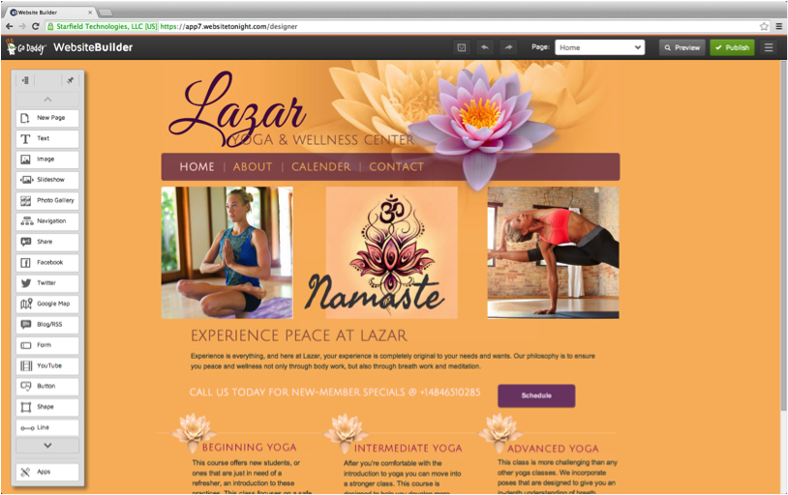

The tool bar on the left side of the screen offers many elements that you can easily drag and drop onto your website.
- The save button allows you to save your work for future editing without publishing your updated site to the web.
- The preview button shows exactly what your website will look like to your audience once you publish it.
- The publish button publishes your site to the web for the world to see.
- The manage site button (next to publish) offers many options to help you customize your site.
  - Locking all layers pins all of the elements on your site, images, textboxes, etc., down to their current position. This prevents frustrating mistakes when you continue to edit your site and add more elements.
  - Grid/Guides help to keep your site pages aligned. You can show Grid/Guides to help align site elements by having them snap to a horizontal and/or vertical grid line. You can even set them to snap to align with other items on the page.
  - Use the Site Settings to update your Site Info, General Settings, Search Engine optimization information, or to backup or restore a previously saved version of your website.
  - Social branding automatically syncs your website theme to match your social network pages, but is only available with the Business Plus plan. With my theme, my Facebook and Twitter accounts would look like this:

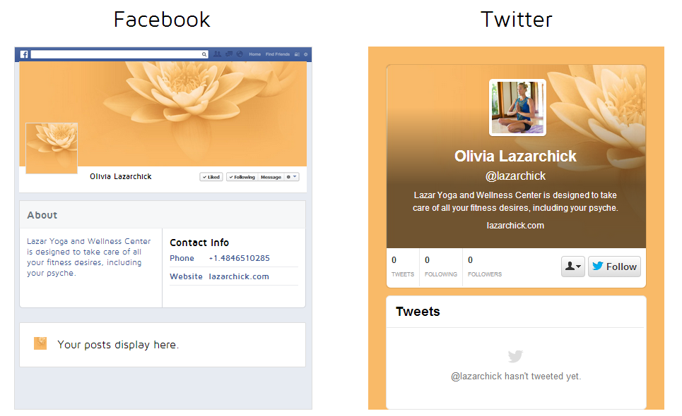

The grey toolbar on the left offers the many elements available for your website.
- You can create a new page, text, image, slideshow, or photo gallery.
- Adding navigation creates a menu so that you can easily find your way to the other pages.
- If you choose to share, your audience can promote your website through their social media through the click of a button.
- To promote your facebook or twitter page, you can add a quick preview and an easy link to like/follow the page.
- Adding a Google map shows your location and allows viewers to easily get directions to your business.
- You can display blog/RSS feeds that let you subscribe to websites such as news sites and blogs, and then display their content on your own site.
- Adding a form allows your viewers to easily contact you with any questions or comments by email.
- You can add YouTube videos to your site.
- Allow your audience to easily navigate your site by adding buttons to link to other pages.
- Shapes and lines can create frames and fun shapes on your site.
- Google® Analytics lets you monitor visitors to your website by adding unique HTML code to your site. This service requires a Google Analytics account.
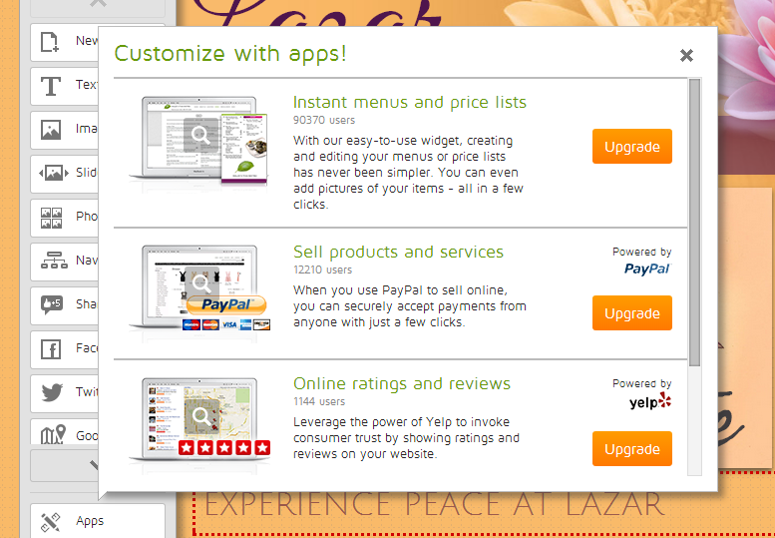
- Website Builder offers many apps to add to your sites with Business/Business Plus plans.

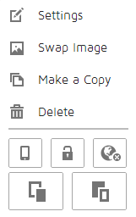
Editing Elements
When you right click on any image, this menu will appear. The menu is similar for all elements, only differing slightly to suit the purpose of that element. In settings, you can add shadows to your image, change the transparency, edit the size, add a link to an image, and more. You can make a copy of any element and move to another location to ensure the same dimensions, font size, etc. The image of the cell phone allows you to hide certain elements to be hidden on your mobile site. The lock allows you to lock the position of the element. The globe allows you to show an element on all pages. This is a good option for a navigation bar, but not an image that is specific to one page. The bottom two images allow you to move the element in front of or behind other elements.

