C++ Game - Minefield -Tutorial
If you are interested in making a character move in C++ this is the right tutorial to learn from. To begin I'll give you a general idea of the program I made in C++. It was called Minefield and the basic concept of it was that you were to control the little X and avoid the bombs that may be in your path. In this tutorial I will show you how I made my program. 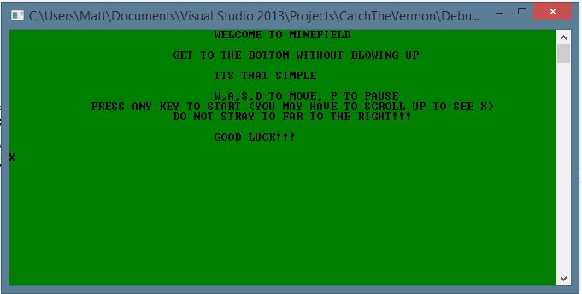
If you were to begin moving your X character and you hit a mine the screen would show this.
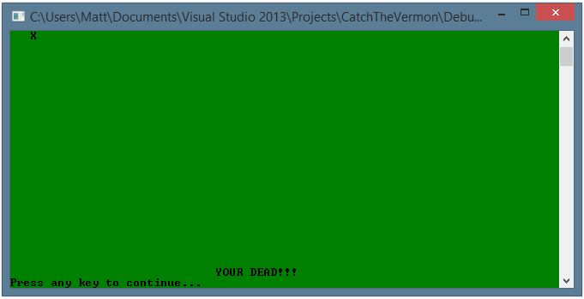
It is a pretty basic concept really. I coded it so that if it hits a certain point on the grid I formed in C++ it would display a death message and exit. So now you may be wondering, if you have not been already, how I actually made the grid. I will show you below. (You can feel free to copy this code, it is by no means copyrighted or plagiarism.)
Starts here (Also can be found on Mr. Minich’s website):
// moving on a grid
#include <iostream>
#include <cstdlib>
#include <conio.h>
using namespace std;
void drawGrid(int x, int y);
//Instances of functions would go here
int main()
{
char userLetter = 's';
int x = 0;
int y = 0;
cout << "X";
while (x != ' ')
{
userLetter = _getch();
if (userLetter == 'w')
{
x--;
}
else if (userLetter == 's')
{
x++;
}
else if (userLetter == 'a')
{
y--;
}
else if (userLetter == 'd')
{
y++;
}
drawGrid(x, y);
}
system("pause");
return 0;
}// end of main
//Functions would go below here
void drawGrid(int x, int y)
{
system("CLS");
for (int row = 0; row < 20; row++)
{
for (int col = 0; col < 20; col++)
{
if (row == x && col == y)
{
cout << "X";
}
else
{
cout << " ";
}
}
cout << endl;
}
}// end of drawGrid
Ends here.
So now that you have that code you may be wondering how you can actually do anything with it. Well you can put it into a compiler for starters and see how it works. Then you may feel free to move onto the next step which is making functions. Functions in C++ are like methods in Java. They work the same way. A function looks like the following and can be used in most applicable situations instead of using multiple and tedious lines of code.
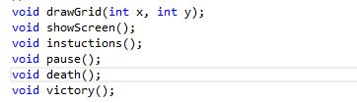
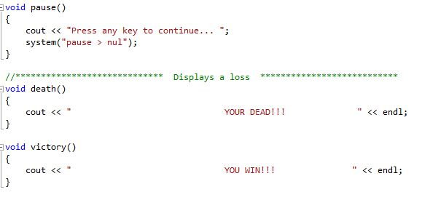
You should be able to see that the functions do things that you would normally do with typical written-out code, they just look nicer. Remember that if you do use functions (which you should) to put all instances of them above of your main class. If you do not understand what this means look for two comments in the drawgrid code that I added to show you exactly the placement I am talking about. By this point you should have everything you need for just a simple grid down. I will now show you how I added color and bombs to my grid. We will start with the color first, because it is really easy.
Add this code below your first main class bracket (You can use any color number you want as long as it is supported:
system("color 20");
Now that you have a color, I will show you how I made the bombs. Each and every bomb is just an if statement that displays a death message and restarts the program. You may add them below move commands (W, A, S, and D).
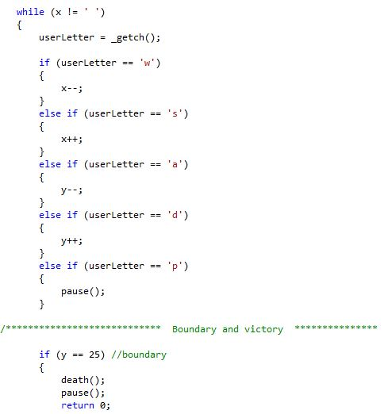
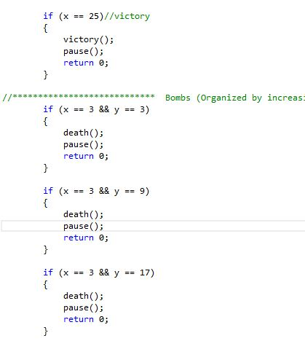
Note: The death function and pause function are shown above.
You should now have everything that you need to know about my program to possibly remake it or make it better. Thank you for taking the time to read my tutorial.

