WordPress Tutorial

About:
WordPress is a free and open source blogging tool and a content management system (CMS) based on PHP and MySQL, and it runs on a web hosting service. Features include a plug-in architecture and a template system. WordPress is used by more than 22.0% of the top 10 million websites as of August 2013.

Background:
WordPress originated in 2003 with just a single bit of code that was used to enhance the typography of everyday writing. Since then it has grown to be the largest self-hosted blogging tool in the world, and it is used by tens of millions of people and found on millions of sites every day. WordPress began as a blogging system, but has evolved and is now used for full content management systems and so much more through the thousands of plug-ins and widgets and themes.
Originally, Word Press was created out of a desire for a well-architectured personal publishing system built on PHP (Hypertext Preprocessor that is a widely used open source general-purpose scripting language that is especially suited for web development and can be embedded into HTML) and MySQL (a freely available open source Relational Database Management System that uses Structured Query Language for adding, accessing and managing content in a database) and licensed under the GPLv2 (or later). WordPress is fresh software and a mature and stable product, and its roots go back to 2001.

Steps to Purchasing WordPress:
- go to godaddy.com
- click on all products at the top
- look under the subheading: Hosting & SSL Hosting where it says WordPress Site/Blog
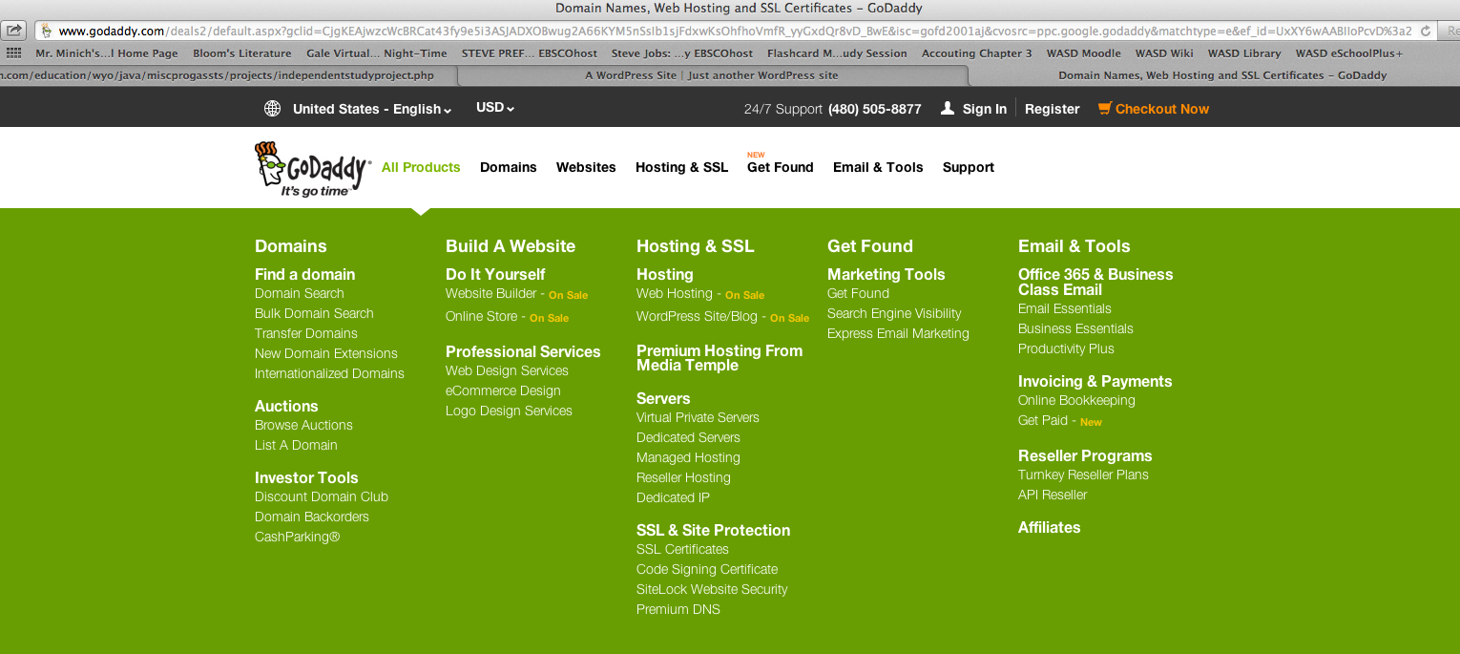

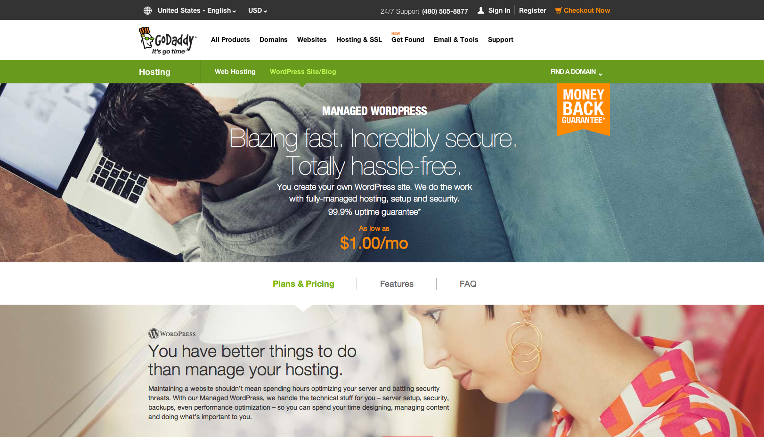
- Click on WordPress Site/Blog. It takes you to a page looking like this:

- Scroll down until you get to this screen:
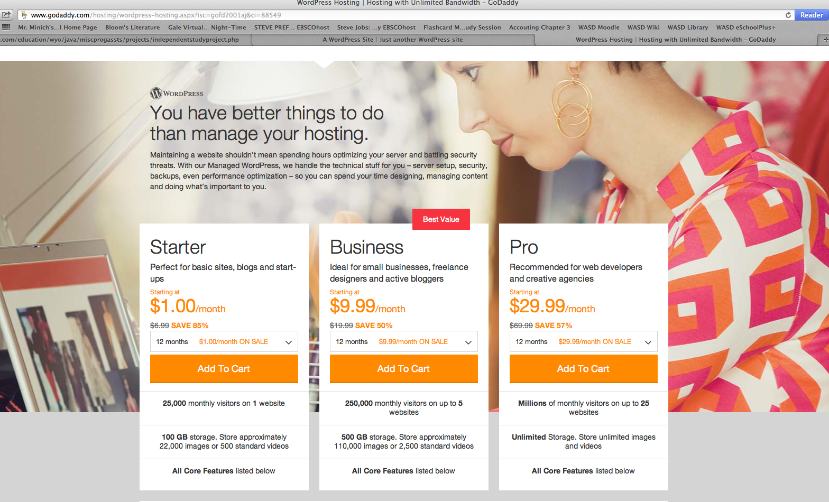

6. These are three options that you can purchase. The Starter is the most simple is perfect for basic sites, blogs, and start-ups. The Business is ideal for small businesses, freelance designers and active bloggers. The Pro is recommended for web developers and creative agencies. I chose Starter for my project.

- Select the amount of months you want WordPress for. And click Add to Cart.
- Now you can enter a domain name of your choice if it is available. I got mine for free because that was what was offered if you signed up for the WordPress software. You can also choose the button that says “I don’t want my FREE Domain >”. I recommend getting a domain.
- Once you find a domain that is available, you click Add and Continue.
- At this point, if you haven’t already, you should sign in to goDaddy and if you don’t have an account you should make one.
- Then you proceed to checkout and you have a website!

Project:
For my independent study project, I created a website using WordPress. I purchased the software through GoDaddy, and with that, I also got a free domain name called cassidykuhn.com. This is a snapshot of the cover page of my website.

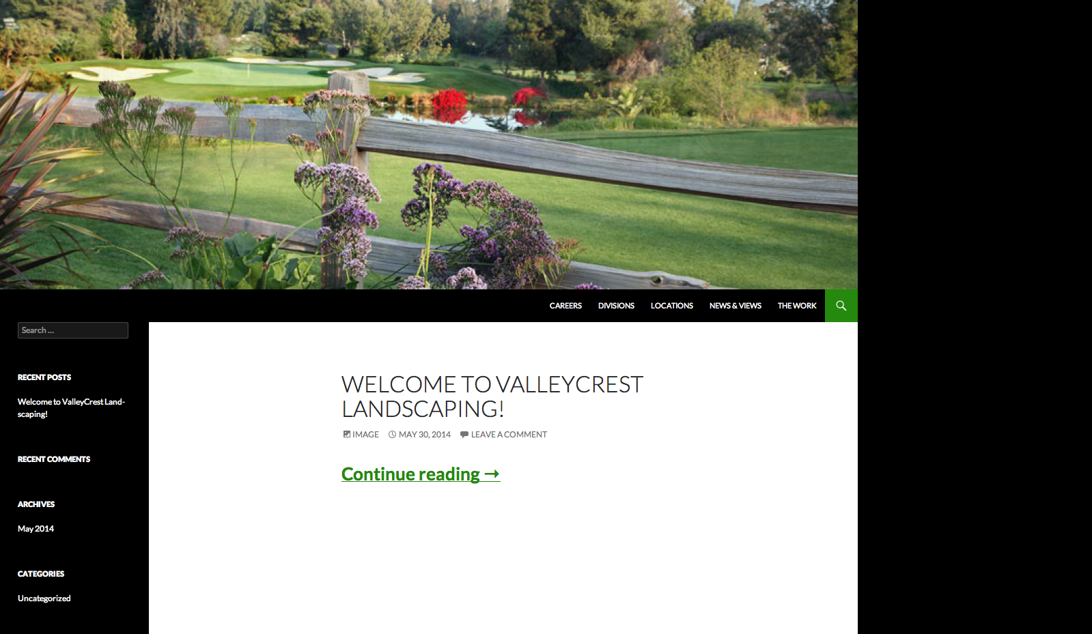

I chose to use the company ValleyCrest Landscaping because there are probably countless landscape companies in need of new and improved websites for their businesses. It was also great for visuals and images eye-catching appeal.

