Scratch Name-
Scratch 2.0 Quiz Period-

- What color is the cat?
- Blue
- White
- Orange
- Red

- What is happening in this script?
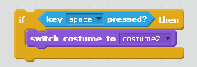

- Changes the costume when the R button is pressed
- Nothing happens
- Scratch hides when the space bar is pressed
- When the space bar is pressed scratch switches his costume to costume 2

- Which category would you find this script?

- Motion
- Looks
- Events
- Pen

- What does this operator do?

- Stops the program
- Resets Scratch
- Acts as a decoration
- Starts the program when pressed

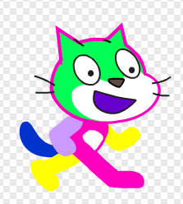
- Where am I able to change his colors?

- Sounds
- Scripts
- Costumes
- Looks

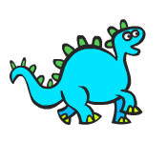
- Where can you get a new character?

- Costumes
- Sounds
- New Sprite
- New Character

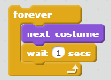
- What is the following an example of?

- An if statement that says if he changes his costume he has to wait 1 second
- A loop that repeats itself
- Sending a message to the user
- Changing the location of the cat

- How do you change the background?
- New sprite
- New Backdrop
- Change background
- Change Stage

- What color are the Pen blocks?
- Green
- Orange
- Purple
- Red

