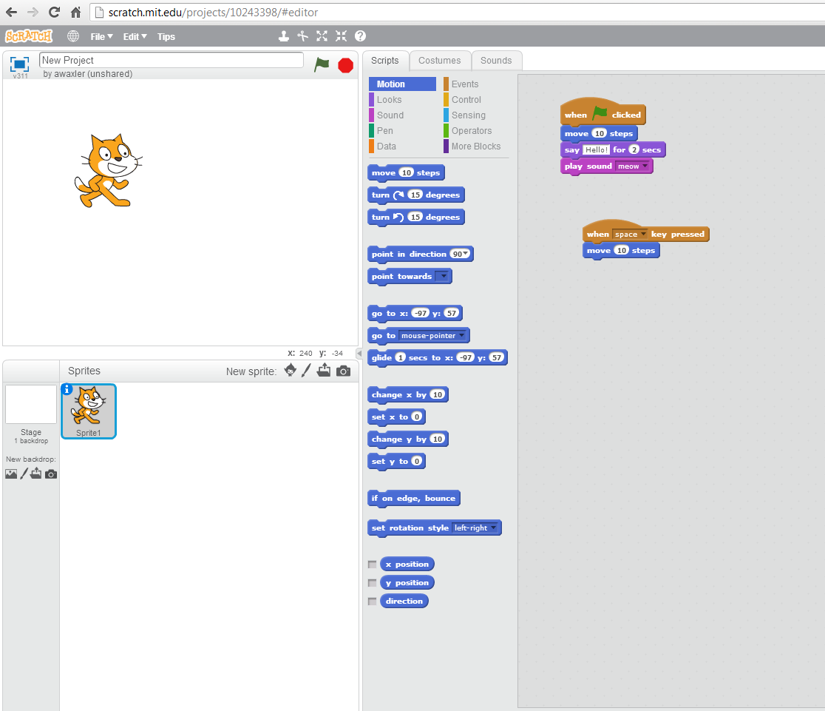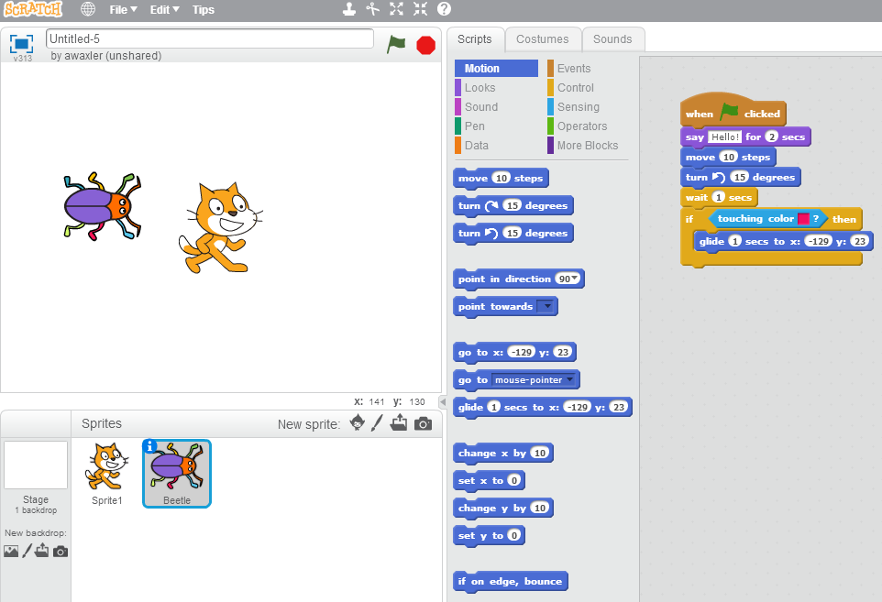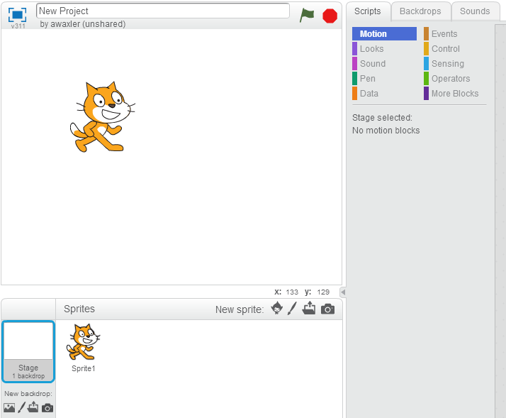

If stage is selected (by clicking this) the “Costumes” tab is changed to “Backdrops”

Stage – click on one of the 4 images to make a new stage

Click one of the 4 images to create a new sprite

Click here for help

Click here to save your program

Click on any of the 3 tabs to go between the sprite’s script, costumes & sounds

To see the script of a different sprite, click on the picture of the sprite

Click on any of the 12 topics to view the blocks in that section

Click on the green flag or red stop sign to start or stop the program

Scratch