HTML5 Tutorials
Brought to You by: Zach
Why you should be learning HTML5
HTML5 is the future of Computer Science! It bridges the gap between web design and multiplatform app development for both IOS and android. Therefore, when you roll out a program, you are covering all the bases and are therefore extending your services to many more fronts. With the cleaner syntax layout and more efficient local storage system as well as added multimedia tags, HTML5 is revolutionizing will be the markup to learn in the coming times.
The Basics
So you now know why HTML5 is right for you to learn, but where must you begin. For a basic idea of what you will be doing, here is an example of the “Hello World” program in HTML5.
<!DOCTYPE html>
<html lang="en">
<head>
<meta charset="utf-8">
<title>Hello World</title>
</head>
<body>
<h1>Hello World</h1>
<p>
Jamie was here.
</p>
</body>
</html>
https://jamiecurle.co.uk/blog/html5-hello-world/

Tags
All of the <> signs that you see are known as tags. Being a markup language (hyper text markup language = HTML), all code executes based on tags. For example, if you wanted to type a paragraph you could do… <p> My name is Zach </p>. Thanks to the start tag, the paragraph is initiated, and then it is subsequently closed by the end tag.

List of other tags:
- Heading - <h1>heading tags</h1>
- Bolding - <p> non bold text<b>bold text</b>.</p>
- Adding images- <img src="smiley.gif" alt="Smiley face" height="42" width="42"> (alt is used as an alternative. In other words it is what happens when the image won’t display. In this case it would be “Smiley face”.
- Makes a table –
<table border="2">
<tr>
<th>Month</th>
<th>Savings</th>
</tr>
<tr>
<td>January</td>
<td>$100</td>
</tr>
</table>
(note* tr is used to define a new row, and th is used to define a cell header.)
- Adds a Video to the Site - <iframe width="420" height="315" src="http://www.youtube.com/embed/zW_ewU14UIY" frameborder="0" allowfullscreen></iframe>

The tags above are a few choice examples, for a complete list of tags, go to http://www.w3schools.com/tags/.

Syntax
Now that you understand the tags of HTML, you need to learn the syntax of the elements, which is quite basic. As far as each individual line, there is a start tag, then the body of the tag (aka element content), and finally the closing tag.
*Important to note* While for the most part the ending tag is considered implied, it can cause errors so try to always include the end tag.

Important to Note
While for the most part the ending tag is considered implied, it can cause errors so try to always include the end tag.
Browsers, such as Chrome, Firefox, Opera, etc…are constantly adding HTML5 support, with the goal of full eventual integration.
Remember that HTML5 is a markup language. In other words, it is much more basic than a programming language. With a markup language, you are essentially building up from scratch.

Integrating CSS
Now that you can structure a web page using HTML, it is time to look into graphics. CSS adds the flashy graphical elements that make sites look nice. With CSS you can add borders, font changes, background colors, and more. CSS stands for Cascading Style Sheets. CSS defines HOW HTML elements should be displayed.
EXTERNAL STYLE SHEET
External Style Sheets are used to apply a certain style to the entire desired web page.
<head>
<link rel="stylesheet" type="text/css" href="mystyle.css">
</head>
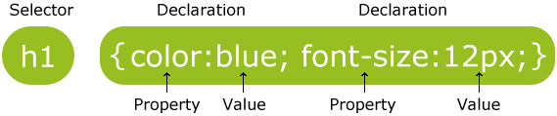
***This image helps to break down CSS syntax with html integration***
*Important* In page design, it is important to find a healthy balance between graphics and content, as some sites go overboard on one or the other and detract from the desired experience
Works Cited: http://www.w3schools.com/html/html5_intro.asp http://www.w3schools.com/tags/

Using Mr. Minich’s site, here are some variants to demonstrate the different applications of HTML and CSS. 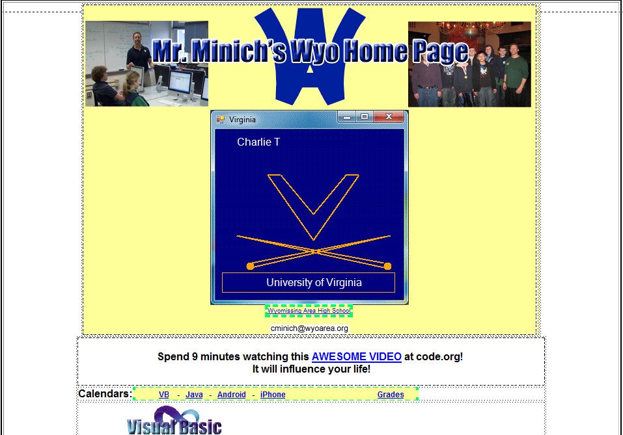

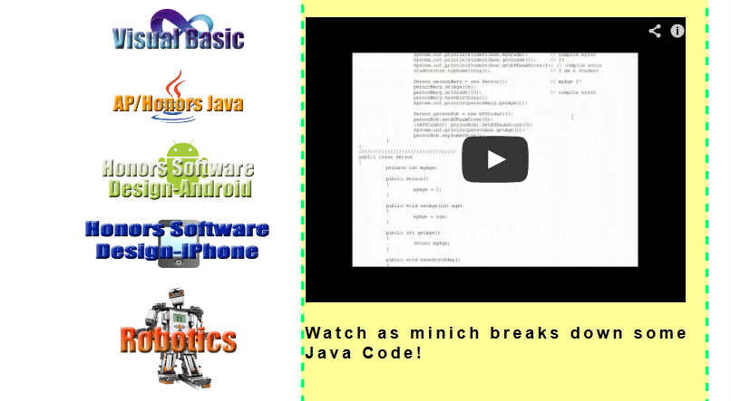
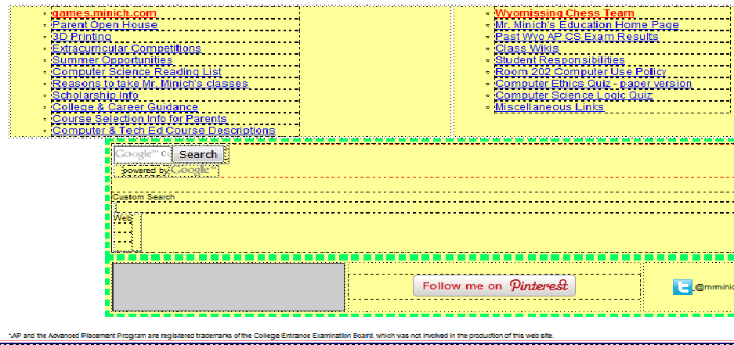

Here is the basic layout of the site, with simple changes made to the original site with the intent of applying HTML and CSS knowledge. Let’s delve deeper into the code to see the applications!

- <p class="pageTitle">Watch as minich breaks down some Java Code!</p> displays
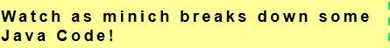

Here we can see the implementation of the paragraph tags, which then subsequently print out the text.

- <iframe width="420" height="315" src="http://www.youtube.com/embed/zW_ewU14UIY" frameborder="0" allowfullscreen></iframe>
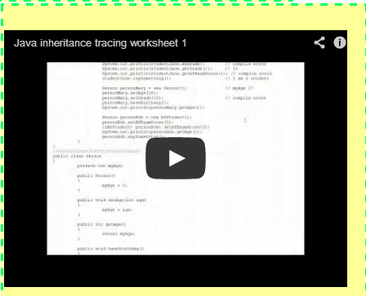
The iframe tags are taking a link from a Youtube Video and implementing a playable version in the video file.

- <img src="./Mr. Minich's Wyomissing Area High School Home Page_files/iphone_header.gif" alt="Honors Software Design - iPhone" width="213" height="61" border="0"></a></p>

The img tag in the program is taking a saved gif file and then adding it to the site. As you can see in the code, the height and width are set along with a border. Also, if the image is not displayable, it shows “Honors Software Design - Iphone” as the alternative.

- <tbody><tr>
<td colspan="2" valign="top"><div align="center" class="columnSubtitle"><br>
<span class="style10">Spend 9 minutes watching this <a href="https://www.youtube.com/v/dU1xS07N-FA#t=0s">AWESOME VIDEO</a> at code.org! <br>
It will influence your life!</span><br>
<br>
</div></td>
</tr><tr>
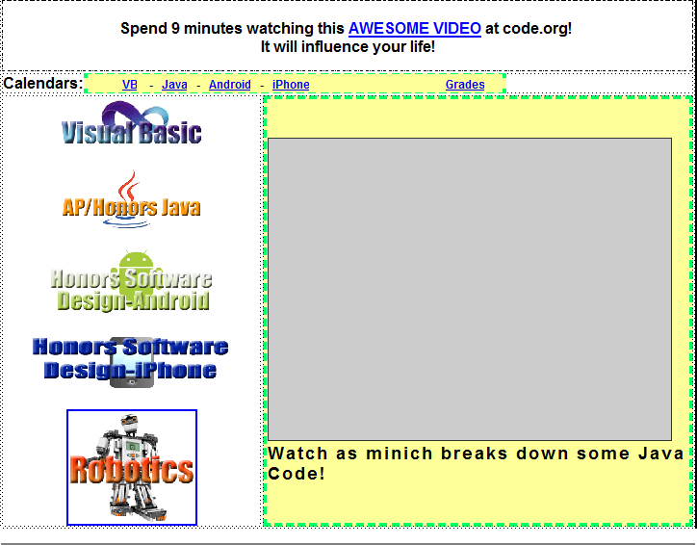
This code group looks fairly complex, but can be broken down fairly simply.

- The <tr> tag is used to establish a row in the program.
- The <tbody> tag is grouping the information found within the table.
- The <div> tag then causes a break in the elements.
- The <span> tag groups the elements.
- The <a> tag is initiating a hyperlink. In this case it is linking to a Youtube video.
- The <br> tag is putting text to the next line. In this case it is putting the “It will influence your life” line below the link to the Youtube video, and then adding a blank line below that.

