HTML5 BrowserQuest
Objective #1: Describe BrowserQuest
- BrowserQuest is an open source HTML5 PoC (proof of concept) MMORPG (Massively Multiplayer Online Roleplaying Game) by Mozilla, the same company that made the Firefox browser. It is a great potential learning medium for HTML5 and JavaScript because the code is public, and it is a fully-functional online game. You can edit it to add items, more textures, etc. You can also edit the map with a free online program.
- Play a Live version of BrowserQuest: You can play the official BrowserQuest game here: http://browserquest.mozilla.org/
Objective #2: Download BrowserQuest from GitHub
- You can obtain the BrowserQuest package here https://github.com/mozilla/BrowserQuest. The link contains the source code of both the BrowserQuest client and server as well as the map files for BrowserQuest
Objective #3: Edit the BrowserQuest Map
- Navigate to the BrowserQuest package you have downloaded. Unzip the file by right-clicking and clicking “Extract All…” Next, download the free map editor Tiled from its website http://www.mapeditor.org/. Open a new file and double click the BrowserQuest folder. Navigate to the directory tools/maps/tmx in this folder and open the map.tmx file. Your screen should looking something like the following:
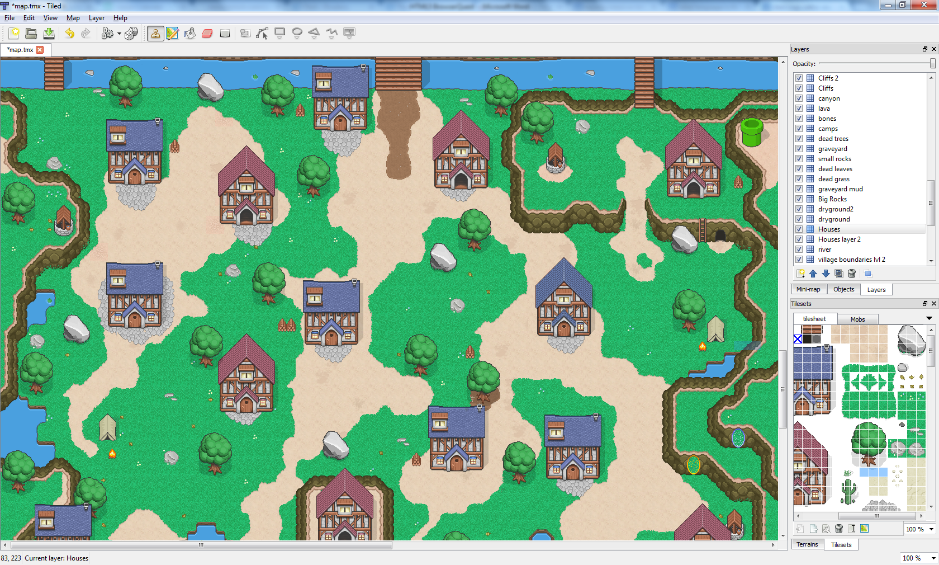
- Now that the map is open, you can edit the map by selecting a layer at the top right panel (only click, don’t check/uncheck visibility). Select one or more tiles in the bottom right panel in the TileSet tab, and place your selection in your map by clicking in the area in the map where you would like to place the tile. Continue with this process until you have finished editing the map to your liking and save.
- If you want to add a custom TileSet, Google for TileSets and download the image file of the TileSet. Then go into Tiled map editor and import the TileSet by going to Map > New TileSet and filling in the resulting information. A new tab should be formed with the name you inputted for the new TileSet. Click on this tab, and simply make a selection to add tiles to the map like normal.
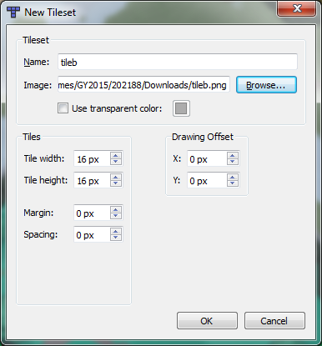
Objective #4: Export the BrowserQuest Map So It’s Live
- To export the BrowserQuest map, you must have permission to the command line. This is probably not allowed on the school computers, so you will need to export all your maps at home or at a computer on which you have administrator permissions. You will also need python installed from their website here http://www.python.org/getit/.
- Open up command prompt (on windows simultaneously press windows key and r and type “cmd” in the dialog box that comes up). On the black box that comes up, navigate to your BrowserQuest folder by typing the command “cd” into command prompt followed by a space and the directory of your BrowserQuest-master\tools\maps folder. My directory is C:\Users\202188\Dropbox\BrowserQuest-master\BrowserQuest-master\tools\maps, so I would type “cd C:\Users\202188\Dropbox\BrowserQuest-master\BrowserQuest-master\tools\maps” into command prompt. Next, type the directory of your python.exe file from the installation, the default is “C:\Python(Version Number)\python.exe.” Do not press enter. Add a space after this directory and type export.py client. “C:\Python(Version Number)\python.exe export.py client” will export the map to the client. Then type “C:\Python(Version Number)\python.exe export.py server” to export to the server. Your map should now be on the BrowserQuest game.

