Programming the Finch with Visual Programmer
Set-Up: Go onto Finchrobot.com. Mouse-over the Software tab and click on Visual Programmer. Follow the on-screen instructions for “Installing the Visual Programmer” to install the program. The Finch robots beak shows several colors if it is ready to go.
Creating Expressions: To create an expression, you first have to click on one of the boxes on the picture of the Finch. For example, you can click on the “Buzzer” box. A box should pop up.
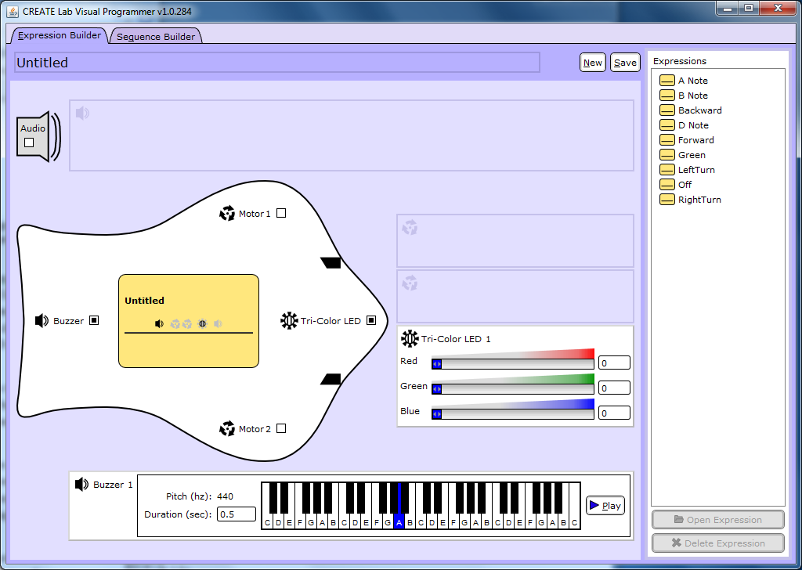
Here you can alter the behavior of the Finch. Then click save at the top-right of the screen. You should now have an expression that when used will cause the Finch to act like how you changed it to. For example, if you click on the “Tri-Color LED” and change the color of the LED to red, when you use that expression in a sequence, it will change the color to red.
Creating Sequences: Sequences are a set of expressions. To create an expression, go in to the Sequence Builder tab where you should find all of the expression that’s you previously built. These expressions should be located on the right side of your screen under the word “Sequences”. Drag the expressions into the middle window. The sequence executes the expressions from top down. Make sure that you add an expression that turns the Finch off at the end of your sequence. To do this, simply create an expression with everything on the Finch turned off.
Creating Sequences with Counters: In Visual Programmer, you can execute sequences a specified number of times. To do this you have to drag the counter button from the bottom-right of your screen. Then drag your sequences inside of the counter window. To change the number of time that the counter executes, click the lock button on the counter window then change the number to whatever you want.
Using the Sensor: To use the sensor on the Finch first drag the sensor button onto the screen. The drop-down box on the top of the window allows you to switch what the Finch is sensing. For example is you select “Temperature Sensor” the Finch will only check the temperature and not anything else. Inside the sensor window works like an if-else statement. If the Finch senses something it is looking for it executes one side of the window, but if it does not sense it, it will execute the other side. 